THE HOLOCAUST AS A STARTING POINT
Advanced training
Northern Ireland

October 20th to 21st, 2026
Location: Belfast

This training is financially supported by:



Training venue
TBD

Participants
30 educators

Working language
English

Coordinators and moderators
Jayne Simms, Education Authority
Denver Charles, History Teachers’ Association of Northern Ireland
Tony Gallagher, Queen’s university Belfast
Bruno Boyer, Mémorial de la Shoah

Pedagogical advisor
Béatrice Munaro, Mémorial de la Shoah

This training is organised by:

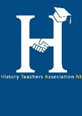
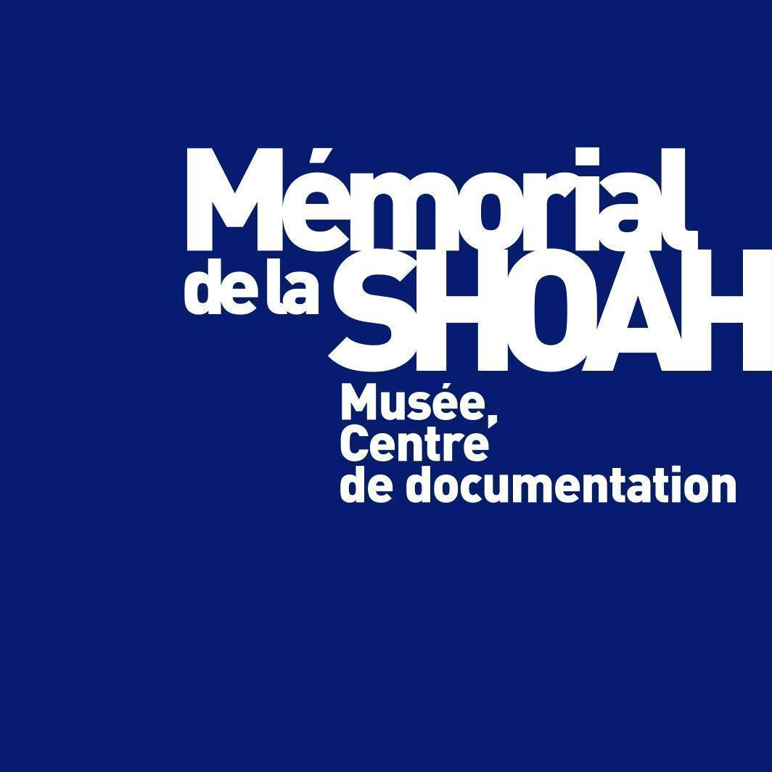


Tuesday, October 20th 2026
9:00 |  | Opening  Ice-breaking activity
9:30 |  | Workshop  Learning Activity 2026  Béatrice Munaro, Mémorial de la Shoah
11:00 |  | Coffee break
11:15 |  | Round table  Holocaust education challenges in Northern Ireland  Béatrice Munaro, Mémorial de la Shoah
12:45 |  | Lunch
13:45 |  | Workshop  Understanding the terminology of mass atrocities  Bruno Boyer, Mémorial de la Shoah
15:15 |  | Coffee break
15:30 |  | Workshop  The times of troubles 1969-1992 an historical approach  TBD
17:00 |  | End of the working day
19:00 |  | Dinner at restaurant

Wednesday, October 21st 2026
9.00 |  | Trainees’ debrief about the previous day
9:30 |  | Historical Lecture  Fundamentals of the Holocaust (Part 2)  Mémorial de la Shoah
11.00 |  | Workshop  Photographing, Reporting and Witnessing the Troubles: using photographs, journalist accounts and oral history testimonies in the classroom  Denver Charles, History Teachers’ Association of Northern Ireland
12:30 |  | Lunch
13.30 |  | Workshop  Voices of conflict and peace: oral history and the legacy of the past in Northern Ireland  Chris Reynolds, Nottingham Trent University
15:00 |  | Coffee break
15.15 |  | Testimonies  Legacy of the Holocaust and the Troubles, a comparative approach
16:45 |  | End of the working day
20:00 |  | Dinner at restaurant

