**THE HOLOCAUST AS A STARTING POINT**

**Beginners training**

Northern Ireland dialogue

From 28th to 29th November 2024

Belfast, Northern Ireland

With the support of:



Training venue

Venue

Crumlin Road Gaol Visitor Attraction and Conference Centre

Audience:

40 participants from Public and Catholic Maintained schools

Languages

English

Coordinators

Jayne Simms, Education Authority

Denver Charles, History Teachers’ Association of Northern Ireland

Bruno Boyer*,* Mémorial de la Shoah

Tony Gallagher, Queen’s university Belfast

Pedagogical advisor

Renata Ozorlic-Dominic, Mémorial de la Shoah

Organized by:

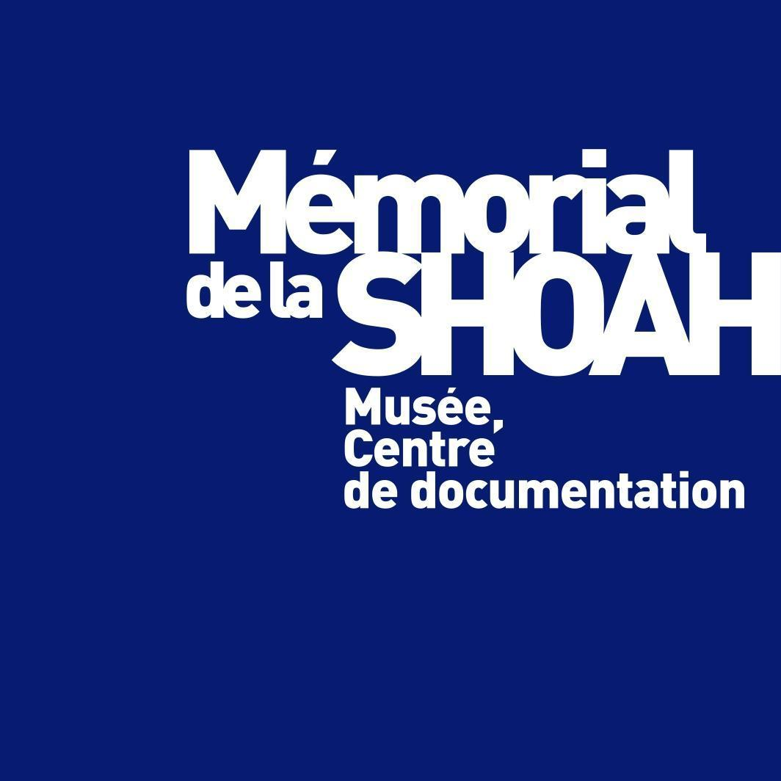

|  |  |  |  |
| --- | --- | --- | --- |
| **Thursday, November 28th 2024** | | |  |
| 9.00 am |  | Opening  Ice breaking activity |  |
| 9.30 am |  | **Workshop**  **Antisemitism today and yesterday**  Bruno Boyer, Memorial de la Shoah |  |
| 11.00 am |  | Coffee break |  |
| 11.15am |  | **Historical Lecture**  **Fundamentals about the Holocaust**  Tal Bruttmann, Cergy Pontoise university |  |
| 12.45 pm |  | Lunch |  |
| 2.00 pm |  | **Historical Lecture**  **UK and the Holocaust**  Martin Winstone, UK Holocaust Trust |  |
| 3.30 pm |  | Coffee break |  |
| 4.00 pm |  | **Workshop 1**  **How to use photography of the Holocaust?**  Tal Bruttmann, Cergy Pontoise university  **Workshop 2** **Building up a common Learning activity**  Renata Ozorlic-Dominic, ETTA |  |
| 5.30 pm |  | End of the working day |  |
| 7.30 pm |  | Dinner in Belfast |  |

|  |  |  |  |
| --- | --- | --- | --- |
| **Friday, 29th November 2024** | | |  |
| 8.30 am |  | **Site vitit**  **Belfast Remembrance**  Tony Gallagher |  |
| 10. 45 am |  | **Historical Lecture**  **What are the 4 crimes of mass atrocities?**  Virginie Sansico, Institut Catholique de Paris |  |
| 12.00 |  | Coffee break |  |
| 12.15  am |  | **Historical Lecture**  **Northern Ireland: a difficult peace?**  Brian Rowan |  |
| 1.30 pm |  | Lunch |  |
| 2.15 pm |  | **Workshop 1 (45 minutes**)  **Photographing, Reporting and Witnessing the Troubles : using photographs, journalist accounts and oral history testimonies in the classroom**  Denver Charles, History Teachers’ Association NI  **Workshop 2 (45 minutes)**  **Once upon a time in Northern Ireland**  Jayne Simms, Education Authority |  |
| 3.45 pm |  | Trainee reports |  |
| 4.15 pm |  | End of the working day |  |